- Purpose
  - The purpose of this document is to describe the procedure for assembling the Lower Frame on the Genesys Machine.
- Scope
  - This SOP applies to all equipment assembly team members. The process applies to the following machine ID’s:
EP50302EQS0600BE1200 – Lower Frame
- Responsibilities
  - The operations manager/supervisor is responsible for enforcing this SOP.
- Materials
  - The proper materials needed for this process are listed on the machine work order.
- Definitions

- Procedure
  - Take 2 head lift arms (E28625) and press a sleeve bearing (E28685) into the hole on each end.
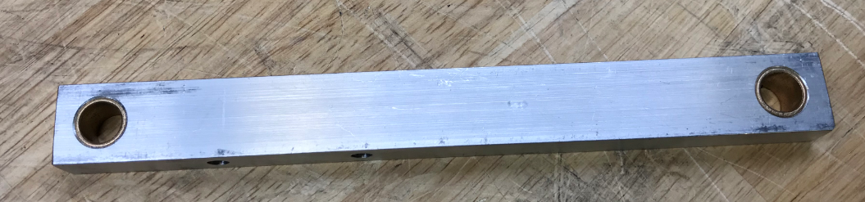
  - Place a frame weldment (E28878) upside down on the table.
  - Attach a microswitch (E28952) to the location shown. Use 2 screws (E28769) with toothed washers (E28821) under the heads. Use a flat washer (E29368) with a nylock nut (E28770) on the other side. Leave them loose at this point.
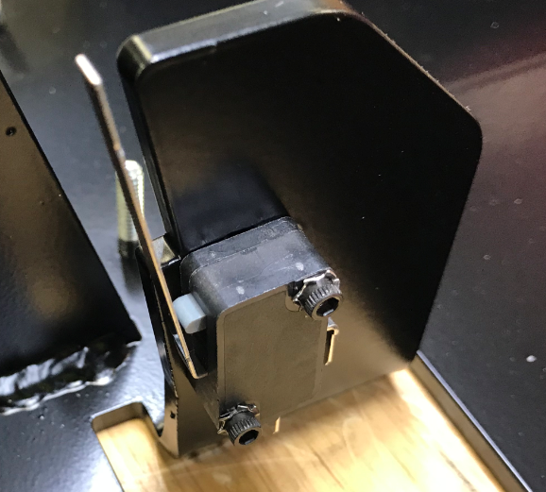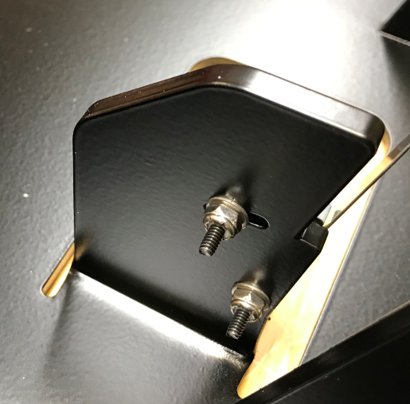
  - Locate the switch in the slot so that you can see a semi-circle visible as shown below. Tighten the switch into place.

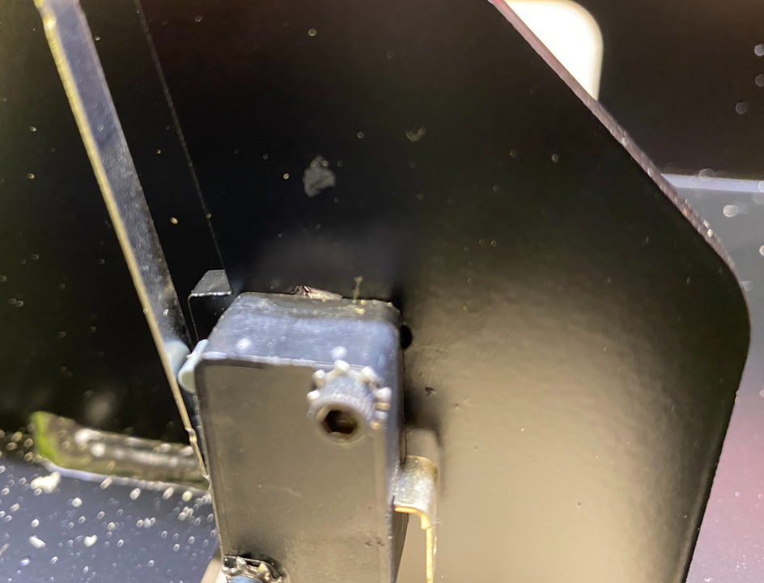
½ round of slot visible

  - Take a static strap (E29459) and cut it to 8” long. Attach it to the squeegee pivot bracket (E28519) using 2 flat washers (E29438), 1 bolt (E29436), and 1 lock nuts (E11146). Ensure the strap is oriented properly.
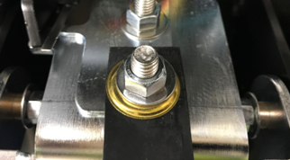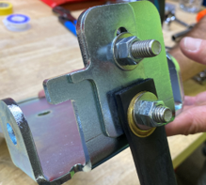

  - Take a squeegee mounting bracket (E28520) and position it in the correct orientation. Note that it will be put together in the upside down position. You want to see the countersink on the hole shown.
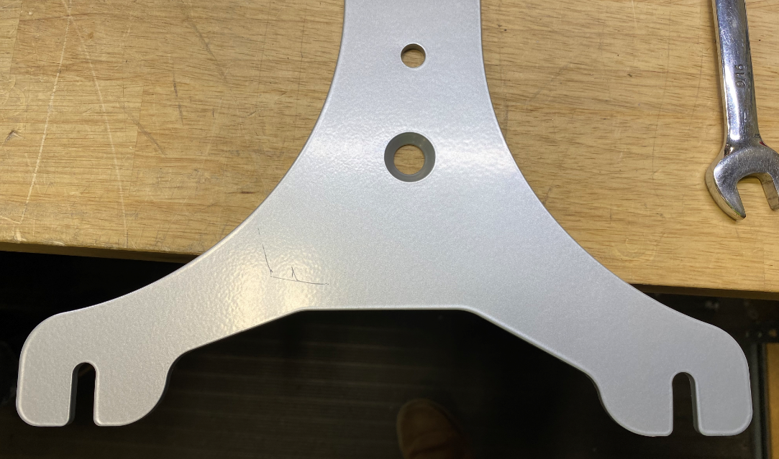
  - Place a hex bolt (E29436) with a flat washer (E29438) through each of the two holes as shown. Then place 2 plastic washers (E28937) over each of the two bolts followed by a sleeve bearing (E28936).
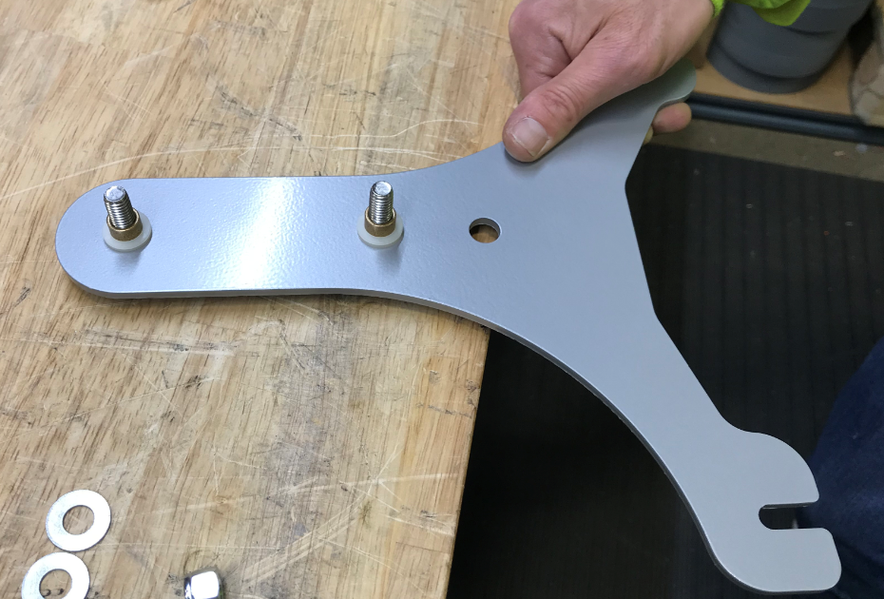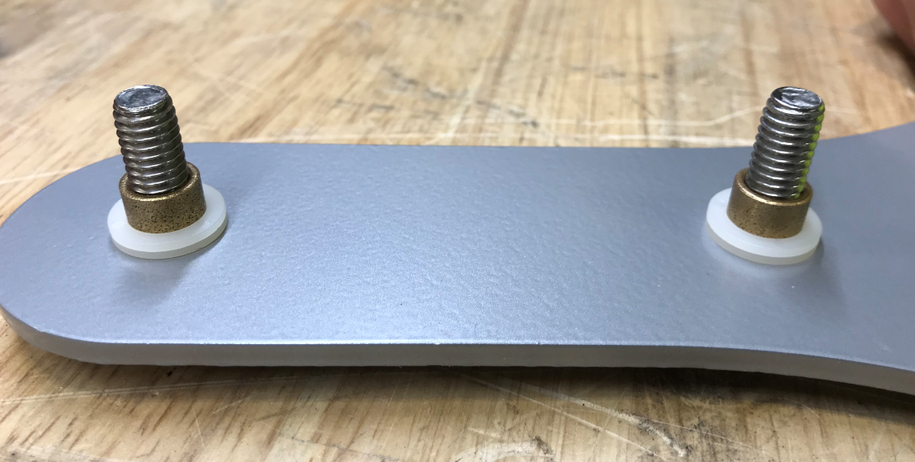

  - Place the squeegee pivot bracket (with the static strap) onto the mounting bracket in the orientation shown. Fasten each bolt with another plastic washer (E28937), flat washer (E29438) and a nut (E11146). The plastic washer goes under the flat washer. Ensure the 2 pieces pivot freely once attached.
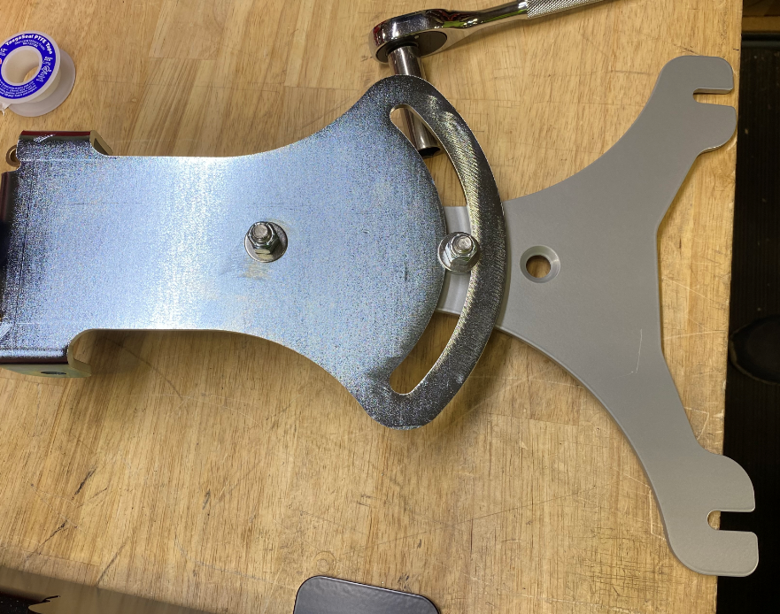
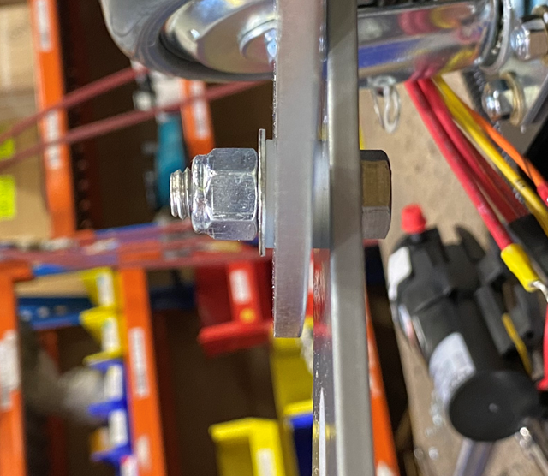
  - Put a flanged sleeve bearing (E28591) through each of the two holes in the pivot bracket. Please note 2 plastic washers (E28937) go in between the two brackets.
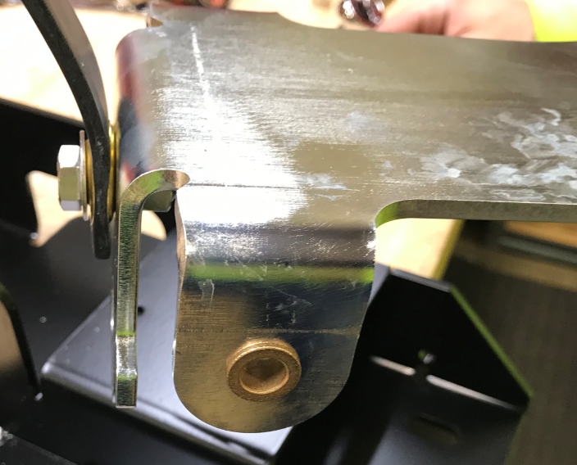
  - Put the pivot bracket into position on the frame and attach using 2 hex bolts (E29436), 2 washers (E29438) under the nuts, and 2 lock nuts (E11146). Put 1 plastic washer (E83145) between the pivot bracket and the frame to eliminate most of the slop between the 2 pieces (Do this only if a washer will fit). Place the washer on the side of the bracket opposite the lift switch. Ensure the bracket actuates the switch properly when it pivots.
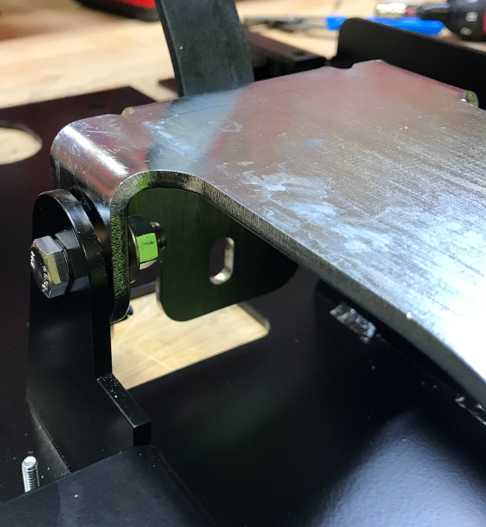
Plastic Washer goes here
  - Attach the swivel casters (E28514) as shown using 4 bolts (E81089), 4 washers (E29403), and 4 hex nuts (E12524) on each. Tighten to 17ft-lbs. Use a paint marker to mark the orientation of the nuts.
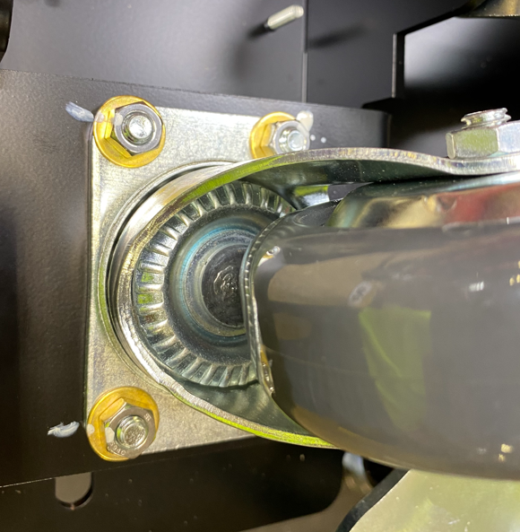
  - Take the 2 head lift arms and install a sleeve bushing (E28684) into the end of the arm furthest from the end with the 2 drilled holes.
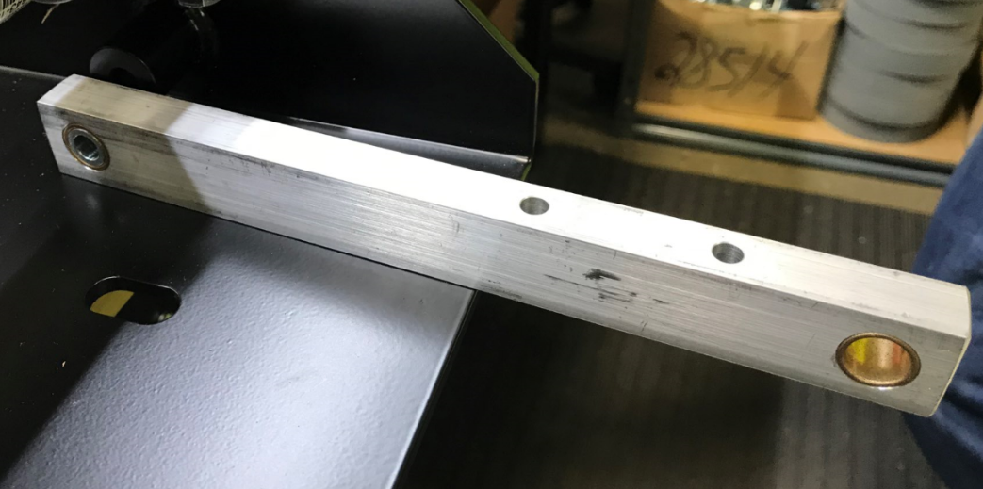

  - Attach each of the arms to the frame using a hex bolt (E28822), 2 flat washers (E28622), and a nyloc nut (E28624). Make sure the arms can pivot.
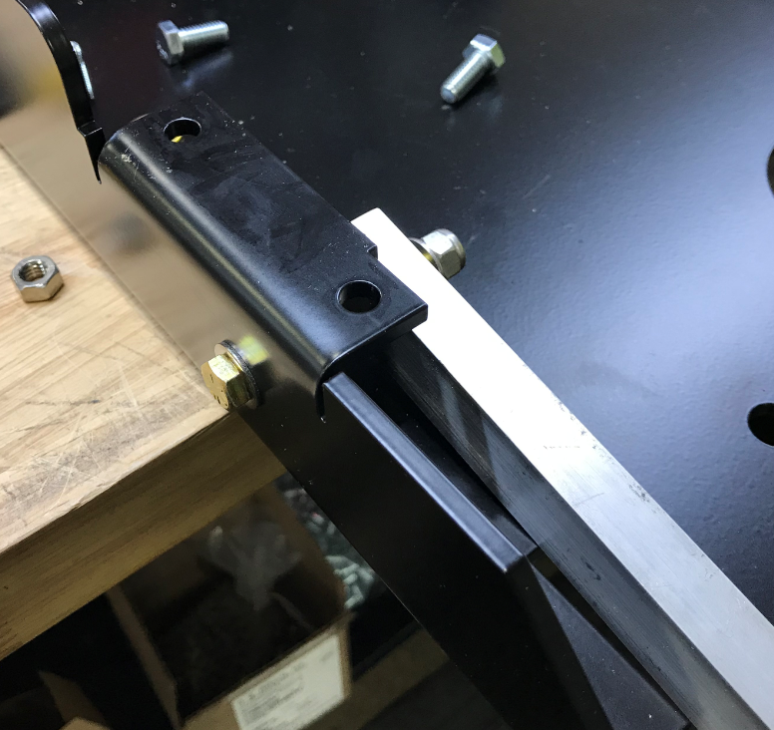
  - Place a transaxle (E28512) onto the proper location on the frame in the orientation shown.
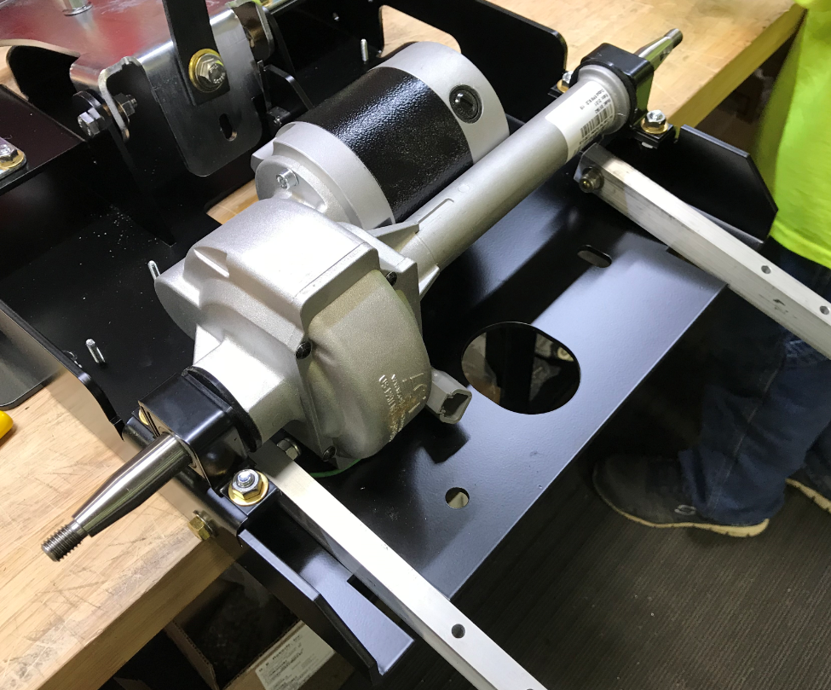
  - Attach the transaxle brackets (E29400) into place using 2 hex bolts (E81089), 2 flat washers (E29403), and 2 hex nuts (E12524). Tighten to 17ft-lbs. Mark the orientation of the nuts using a paint marker.
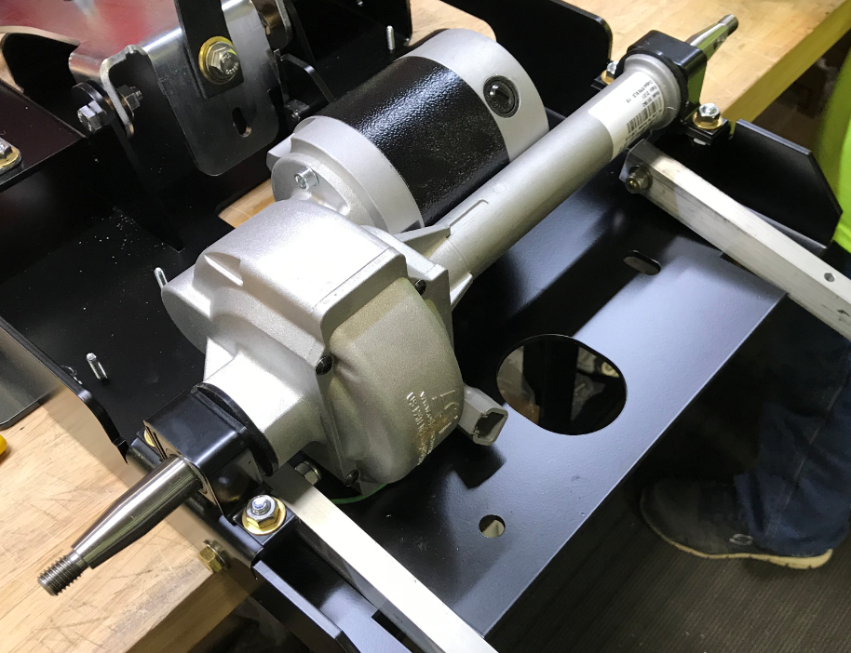
  - Take the appropriate wire harness (E29200-Standard Disc / E29210-Standard Orbital). If it is a Disc harness, place a piece of yellow tape around the red and black motors wire labeled 12A and 10H. This tells the assembler which motor is on the operator left side.
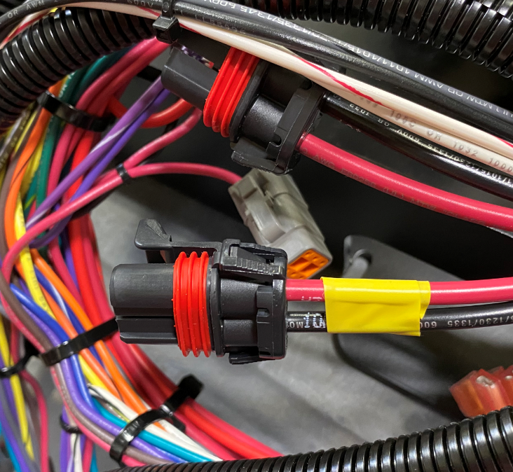
  - Feed the wire harness through the frame as shown. Ensure the wires for the pump, transaxle, etc are located properly.
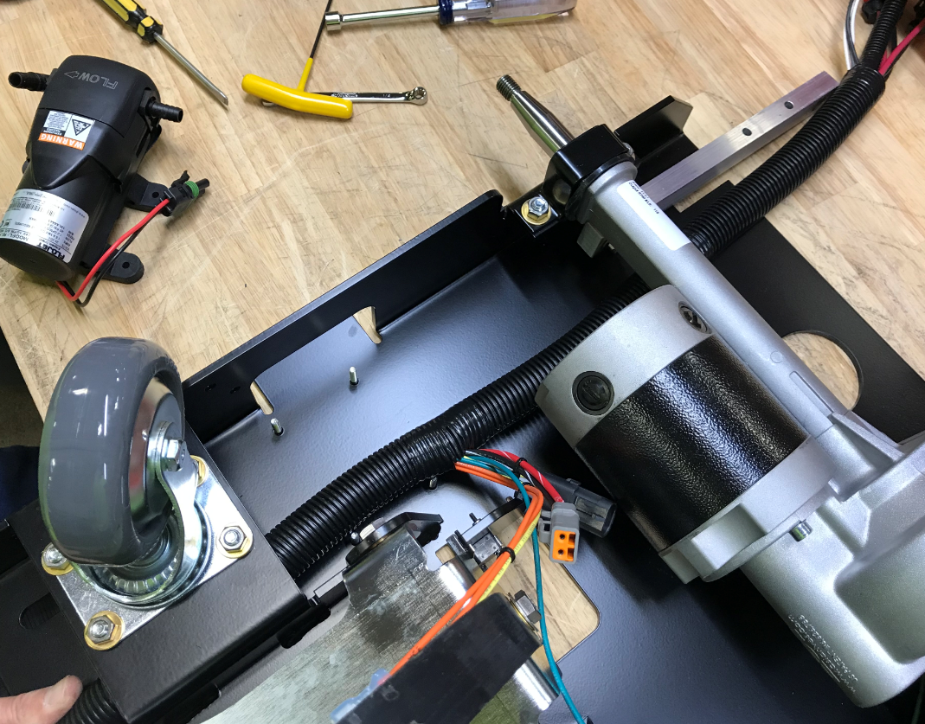
  - Move the harness out of the way and mount the pump (E29601) to the threaded studs using 4 washers (E28775) and 4 nuts (E28753). The pump has rubber feet so do not overtighten. Tighten by hand or use the small nut driver on setting “5”. **QC Check – Nut Installation**
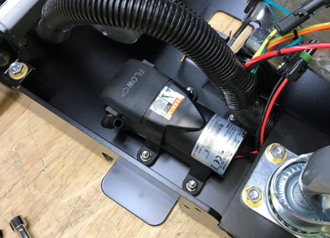
  - Remove the fitting from the inlet side of the pump, press the wire harness down under it, then . This is easier that trying to push the harness past the fitting.

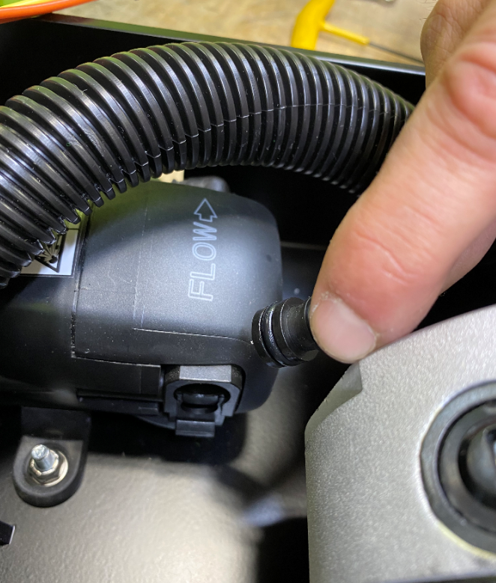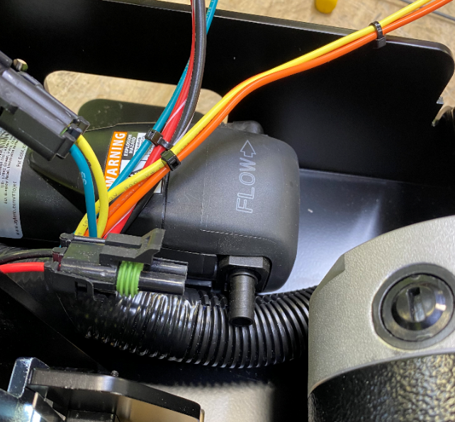

  - Attach the appropriate connector from the pump to the harness.
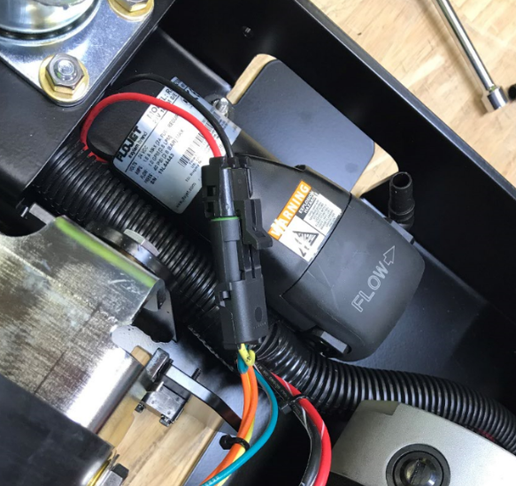
  - Attach the appropriate connector from the transaxle to the harness.

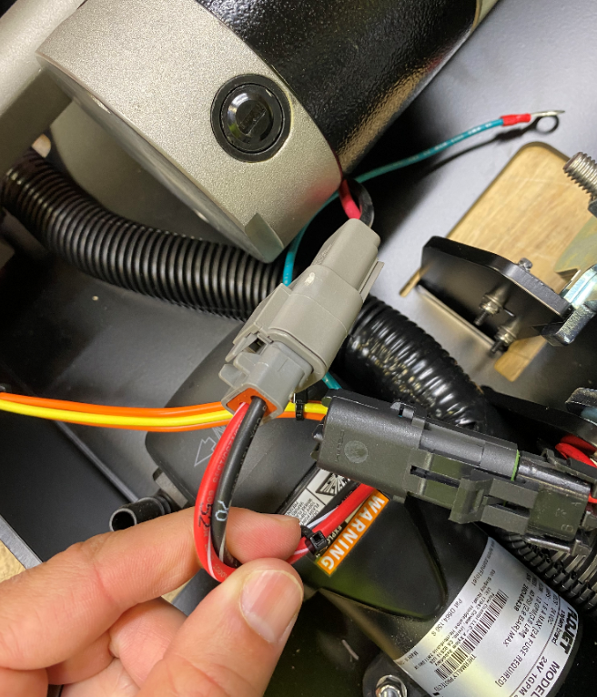

  - Take a strainer (E28942), unscrew the cap, and place it into a mounting bracket (E28740). Locate the arrow on the strainer to ensure the flow direction.
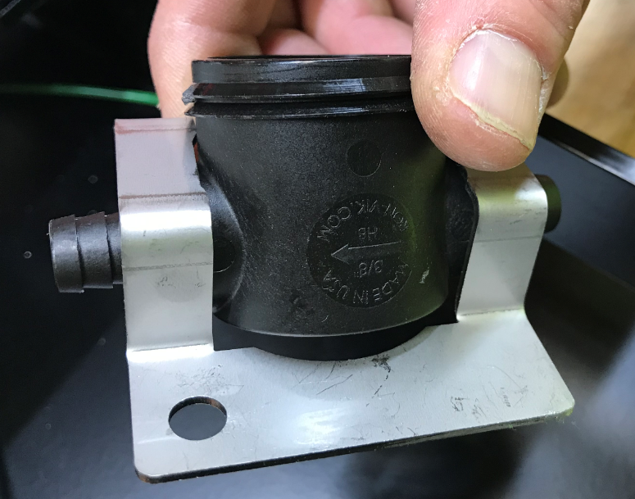
  - Mount the bracket to the frame with the arrow on the filter pointing towards the pump. Attach the ground wires from the harness and the transaxle to the same threaded studs using 2 nuts (E28753). Put the cap back onto the strainer.
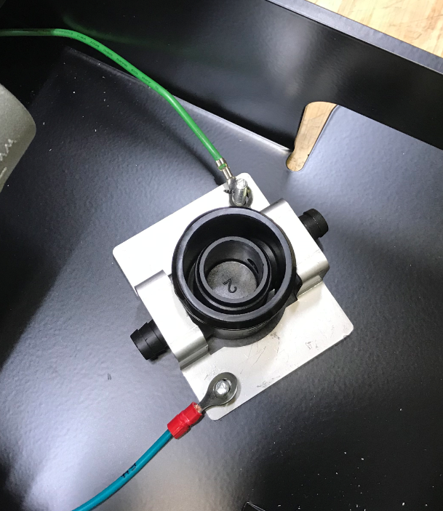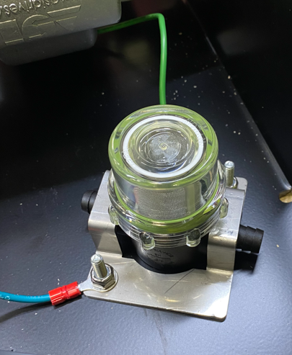
  - Take a ball valve mounting bracket (E28746) and attach it to the frame using 2 bolts (E29410) and 2 nuts (E28853).
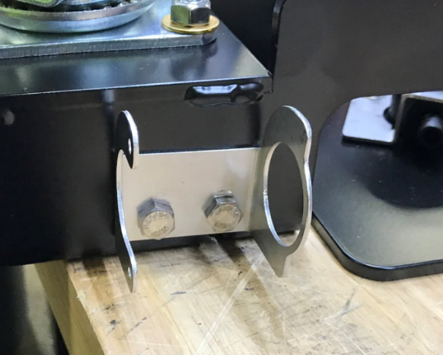
  - Cut a 5 ¼” piece of tubing (E28620) along with a 2 ½” piece of tubing. Install the tubing on each side of a check valve (E28816) as shown. Connect this assembly between the strainer and the pump. Use a worm clamp (E89720) on the pump end. Ensure the check valve is in the orientation shown.
Check Valve
2 ½”
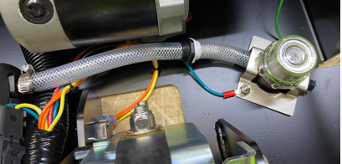
Clamp
5 ¼”

  - Take a ball valve (E28940) and thread a ¾” barbed fitting (E28752) on the inlet side and a 3/8” barbed fitting (E28751) on the outlet side. Put some thread tape on the fittings first.

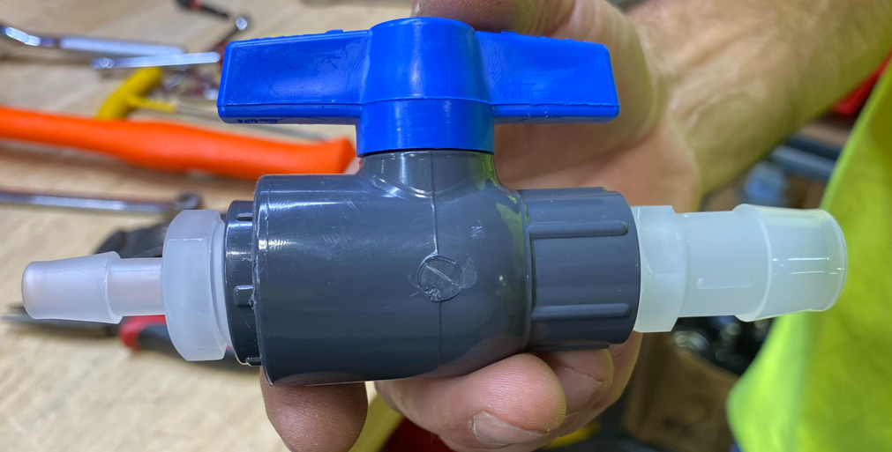
  - Cut a 5” piece of tubing (E28620) and install it onto the outlet end of the ball valve as shown.

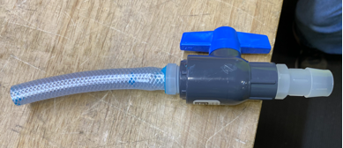

  - Feed the hose through the mounting bracket hole and the cutout in the frame and connect it to the strainer. Then position the valve in its mounting bracket.
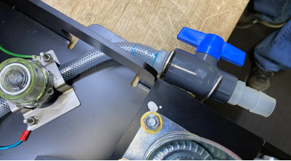
  - Use a zip tie (E28831) to secure it.
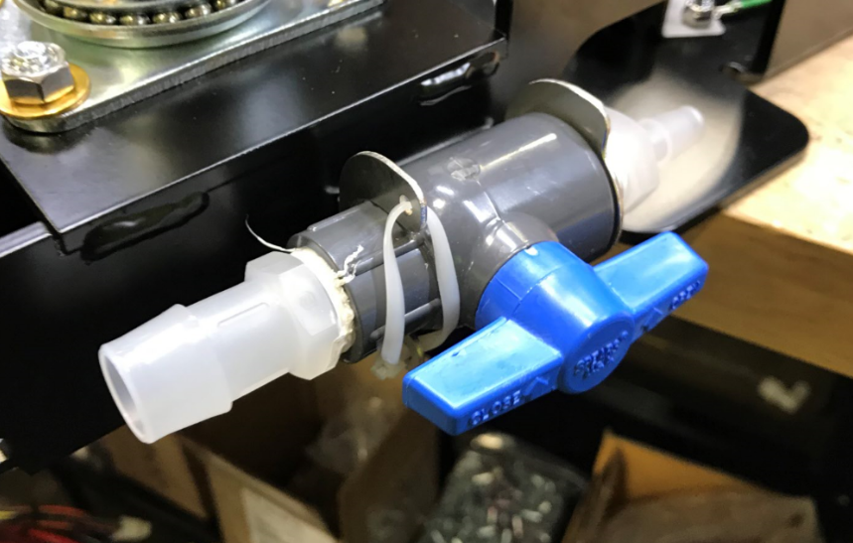
  - Cut a 38” piece of 3/8” tubing (E28620) and attach it to the outlet side of the pump using a clamp (E89720). Ensure both the hose and the wiring harness pass under the transaxle as shown.
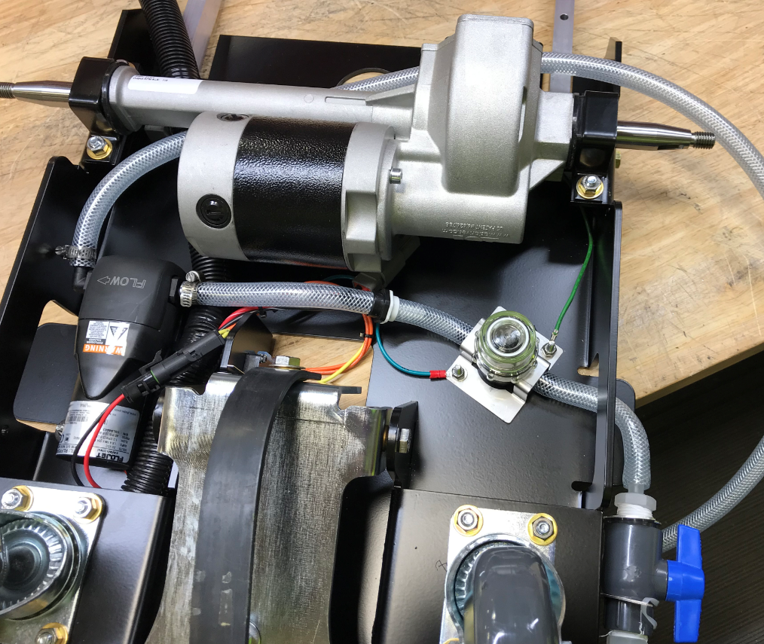
  - Place a woodruff key (E29439) into the slot on each side of the transaxle.
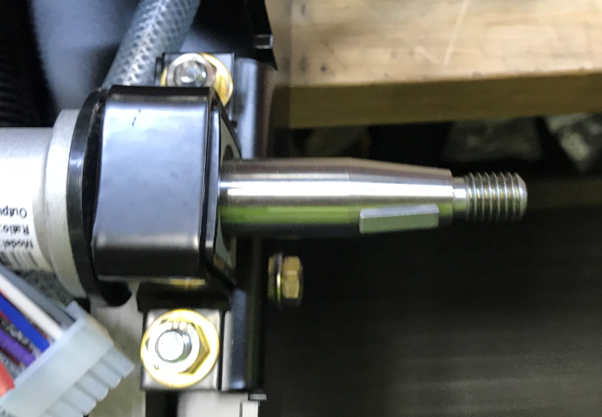
  - Attach a wheel (E28515) onto each end of the transaxle using a flat washer (E83702) and a nyloc nut (E86489). Line the wheel up with the key before tightening. Do not overtighten this connection. Tighten the nut to 17ft-lbs. Mark the orientation of the nut with a paint marker.

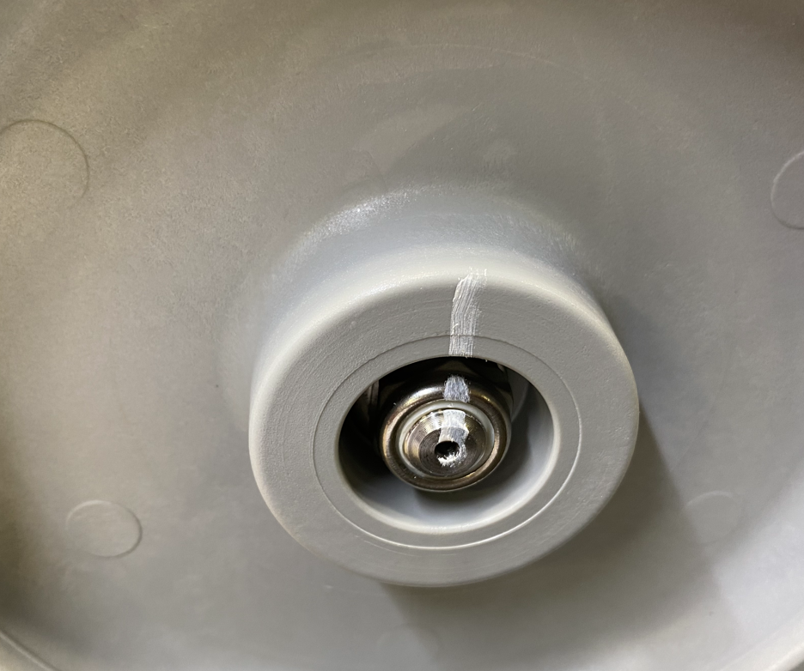

  - Set the frame up on its side and connect the appropriate terminals to the microswitch.
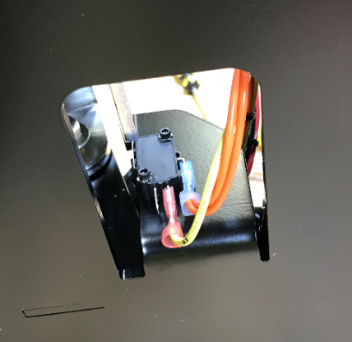
- References (optional section as needed)

- Training Guide

Functional Training Groups Requiring Training
Equipment Assembly Group

- SOP Change Control

Date of Change | Reason for Change
TBD | This is the first version of the S.O.P. hence there are no revisions to this document.
8/13/2021 | Added QC Checks and torque specs
11/7/2023 | Updated to current process
5/9/2025 | Updated

Approvals

Submitter/Author Approval:__________________________________ Date:______________________

Management Approval:______________________________________ Date:______________________

QAU Approval:_____________________________________________ Date:______________________

